B8IT121 CA Assignment

**ASP.NET Web Application – Dingle Running Festival**

Eoin O’Malley 10378539,

Patricia Tobin 10379820,

Aristotelis Tzamtzoglou 10376799

21/12/2018



Table of Contents

Table of Contents ii

List of Figures ii

1. Web Application Overview 3

1.1 Introduction 3

1.2 Application Idea 3

1.3 Target Audience 3

1.4 Structural Diagram 3

1.5 Technologies Used 3

1.6 Strengths and Weaknesses 3

2. Back End 4

2.1 Database Design (ERD) 4

2.2 XML 4

2.3 Testing 4

3. Front End 5

3.1 Visual Design 5

3.2 Search Engine Optimisation 5

3.3 Testing 5

4. Bibliography 6

List of Figures

No table of figures entries found.

## Web Application Overview

### Introduction

The objective of this CA project is to design and implement an interactive web application for a fictitious event namely the Dingle Running Marathon Festival. This web application is based on the real Dingle Marathon Event which is held every year around the Dingle Peninsula. The web app will allow first time visitors to become members of the web site and/or register for the Dingle Marathon Racing event on September 29th 2019.

### Application Idea

The Dingle Running Festival web application incorporates the following three components

a) It contains a relational database that will contain all data personal registration entries from the runners

b) It will output on a XML native database runners’ registration details

c) The app will be deployed on the Azure cloud platform as it must be functional at all times from any location

Before creating this web application, our group determined that the app should exhibit the following features:

* **Interactive** so that the user can input data on the forms online and expect the system to return output messages
* **Dynamic** as it needs to load the content fast which is very important when an application is accessed with a mobile device
* **Flexible** as the application should run from any device where there is internet connection
* **User Friendly** as the application must contain easy to navigate menus, diagrams and side bars
* **Responsive web design** that allows the web app to be accessible from all users on different types of devices on different screens

The Dingle Running Marathon web app is applied to the marathon event around the Dingle Peninsula and has all the information needed for a new runner to participate. First of all, the site visitor can register on the web site and then become a member to receive the newsletter. In addition the new user can choose one of the following race types so as to participate after paying the appropriate race running fee

* Family 5K which is the shortest type of race covering a distance of kilometers or 3.107 miles. This race is the most popular of all race types because it targets all types of people to participate as the easiest of all without previous marathon running experience
* 10K which covers a distance of 10Kms or 6.2 miles and it also quite popular as it applies to a wider range of people who are not experienced marathon runners
* Half Marathon

The half marathon is a road running event of 21.0975 km or 13 miles and the route path is shown on the Dingle Map. All runners are advised to read information about this race so as to prepare themselves in advance before attempting the race.

* Full Marathon

The marathon is a long-distance race, completed by running, walking, or a run/walk strategy and includes wheelchair divisions.

The marathon has an official distance of 42.195 kilometers (26.219 miles). All runners are recommended to read race details so as to prepare themselves in advance before attempting this race

### Target Audience

This web application directs all people interested in participating in the Dingle Running Marathon Festival on September 29th 2019. It is open for registration for all people living in Ireland but there are some rules for entry which are outlined in the terms & conditions. This running event is quite popular as the marathon path scenery around the Dingle Peninsula is spectacular.

### Structural Diagram

This structural diagram represents the timeframe for the project which is the skeleton of the web application.

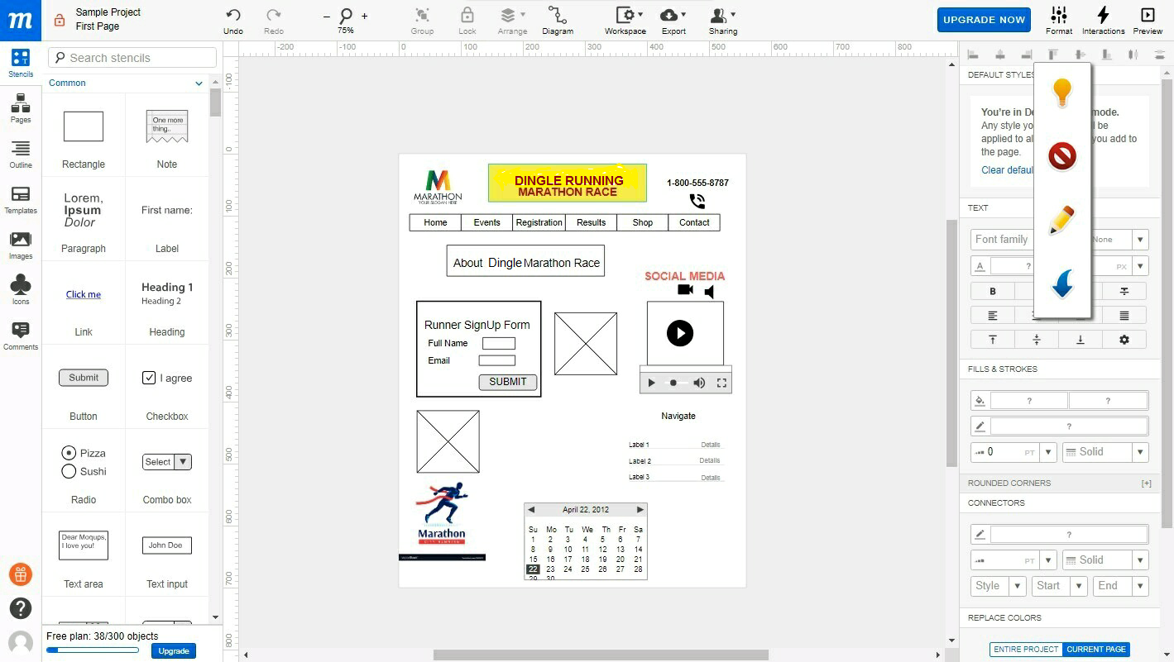

### Technologies Used

There have been several technologies used for this project which are outlined as follows:

1. The web site for this app was designed with HTML5 & CSS technology using Notepad++
2. For the design of models, controllers and views, ASP.NET MVC Framework was used which is the most recent topic covered in the CA module
3. C# was used throughout this project for the construction of classes whereas Microsoft SQL Server was used to construct the four tables namely Account, Orders, Race and Results.
4. Microsoft Visual Studio Enterprise 2017 Version 15.8.4 was used as the software application to combine all such different aspects of the project

### Strengths and Weaknesses

Our group has developed this web application for the Dingle Running Marathon Event and here is an outline of the strengths and weaknesses

**Strengths**

* **Instant Immediate Accessibility** As all web applications, there is no need to download it from a Store but instead they are accessible anytime from the cloud with the use of a client browser.
* **Easy to maintain** The code is the same across all platforms so it is easy to maintain
* **Fast update** when there is a need to apply updates, the developer will make the new changes on the cloud platform online and such new data will replace the old version. Thus by just by clicking on the web application url web address, it will display the updated new version
* **No need for App/Google Store permission/approval** All web applications including the Dingle Marathon Festival is can be released anytime the develop wants
* **Compatible with old devices**

**Weaknesses**

* **Costly and difficult to maintain** all web applications run on different devices with different browsers so it is impossible to provide support for all of them. That is if there is a failure on a particular device or browser, then difficult to provide app support for this particular instance.
* **Not listed on the App Store** It is difficult to find them because they are not listed in a centralized store location
* **Lack of technical support** It is also difficult to provide support the application because it runs on a multitude of platforms and browsers.
* **Lack of security** the application is not as secure as a native app installed on a device because there is no process to confirm for its safety. Those application on a Store are normally safe to download and use
* **Google Analytics** cannot provide usage support as this web application is accessed from any type of device with any kind of client browser
* **Offline use is NOT possible** the web application is operational when there is a live internet connection only so the user must always be in a place where there is an internet connection.
* **Not possible for push notifications** such notifications are pop up messages sent on a device by the app publisher. Push notification are like SMS text messages and alerts but they reach users who have installed the application – iOS, Fire OS, Windows and Blackberry have their own services

## Back End

### Database Design (ERD)

The Database Design (ERD) includes the following (4) tables:

1. **Account**

This table allows the user to register and create a new account with personal details and register in the website by a unique email address

1. **Orders**

This table allows to make an order for the race after inserting all runner’s details

1. **Race**

This table contains data for each of the four (4) races, that is 5K, 10K, Half Marathon and Full Marathon as identified with a race id

1. **Results**

This table contains data for the runner once the race is over as it will retrieve the finish time based on the bib no applicable to the runner

At the first page at the top right section, there are two (2) options for any web site visitor

1. First time visitors can become members of the site by creating an account with their personal details
2. Existing members can log into the site and do one of the following five (5) things

* Enter the 2019 Dingle Running Festival race by filling out a form which asks to fill in personal details, race type, t-shirt size, card type and card holder details
* Make changes to the original registration which allows them to change the original t-shirt order or race type
* Change the web site password associated with the account
* View past orders associated with the account
* Give Feedback for the participating event

Here follows below the ERD diagram that shows the interrelationship between the four tables

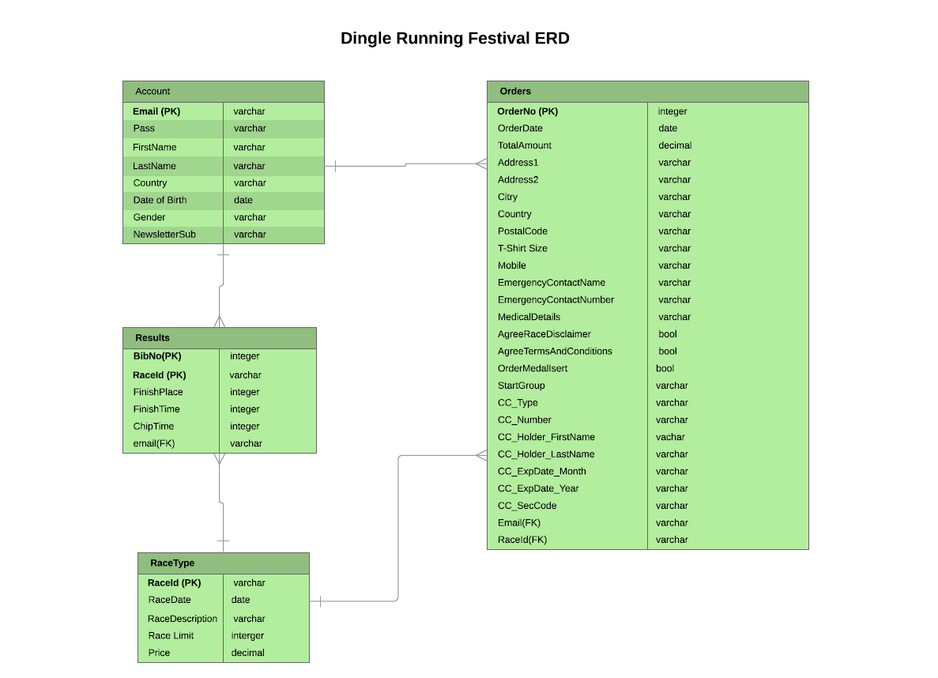

### XML

The XML database is native as there is no need for high performance results with use of memory resources. The aim is to write a new file in xml format which will contain the runners’ list with all details. The scope is to output as feedback the comments of the athletes who participate in the race.

### Testing

We have tested the application and it is functional for the following components

* Visitor web site registration page
* Existing member login page
* Enter the 2019 Dingle Running Festival link
* Member’s Account settings modification link

There must be more work on the ‘Give Feedback’, ‘Make Changes to Festival Registration’ and ‘View Past Orders’

Finally there should be a progress in the RESULS tab option as this should allow the user to find the finishing time by the bib no.

## Front End

### Visual Design

The web site for this web application has been designed using Notepad++ which allows to write HTML5 and CSS code. The main page contains slideshow effect, social media links, clear colorful navigation menu with pop-up menus, race calendar events, previous runners’ testimonials about the race and a web site map. There is responsive web design for the web site of this app which allows web pages render well on a variety of devices and window or screen sizes. Content, design and performance are necessary across all devices to ensure usability and satisfaction.

### Search Engine Optimisation

SEO (Search Engine Optimization) is important as this would bring up this web site at the first page of the search engine results. Our group used key word terms for this project such as ‘marathon’, ‘running’, ‘5K’, ‘10K’ which are generic for any marathon web site. But for the scope of this project, our group used specific terms for the Dingle Running Festival. Specifically this marathon event is situated around the Dingle Peninsula so sightseeing local attractions such as “Dingle Peninsula”, “Dingle Bay”, “Slea Head” and “Dunmore Head” have been used. Thus visitors can search by such terms in order to find more information and then browse through the web app to get registered.

### Testing

This includes web application testing in different types of devices such as smartphones, laptops and desktop PCs. The app should be functional when a live internet connection exists from any location.

#### Browsers Used

The Dingle Running Marathon web application is operational on a number of different browsers such as Mozilla Firefox, Microsoft IE, Apple Safari, Google Chrome and Opera. That is the app is consistent with all major browsers as every user will access the app from a different device with a different client browser

## Bibliography

**There are no sources in the current document.**

<https://www.reliablesoft.net/what-is-search-engine-optimization-and-why-is-it-important>

<http://www.coolrunning.com/engine/2/2_4/131.shtml>

<https://www.runireland.com/>

<https://www.apppartner.com/native-apps-vs-web-apps-strengths-and-weaknesses-you-need-to-know/>

<https://www.urbanairship.com/push-notifications-explained>

<https://www.altexsoft.com/blog/engineering/progressive-web-apps/>